Using the FixIt – FindIt Utility (FIXIT.EXE)
The Fixit utility centralizes approved SQL Server related solutions to solve officemate issues. A key component of running SQL scripts on office servers is the requirement to make a courtesy copy of the database in case the SQL activity causes an issue and the state of the data needs to be restored to a point prior to the support agents actions.

What does it do
The application, in some cases, run sql scripts from the most common OfficeMate solutions, without the user needing to write, modify, or copy and paste any sql scripts. It also removes the need to logon to the server, allowing the same solution processing from the client’s workstation.

The application will log the items it makes changes to, and save the log in the OfficeMate data folder on the server.

Some solutions will display an interactive screen allowing the user to select which records should be processed with the solution or simply display information to the user.

The solutions will be listed for selection in the format “Solution Number – Solution Title”, where the title is the same as shown in EyeForce.

Where is the file located
The file is attached to solution #7257 and should be transferred to the client’s desktop

- Navigate to solution#7257 in EyeForce.
- Click the View link for the attached file at the bottom of the solution.
- Right-click on the View file link and Save As, to select your desktop as the location.
- Transfer this file to the client’s desktop using appropriate remote (webex) procedures.

Version & Change Control
The file will be periodically updated and attached to solution #7257.
The previous version and current version will be maintained in the solution for download.
An email will be sent to Eyefinity support community using the appropriate distribution list.

How to run the Application

- Double-click on the file to launch FixIt.

- Click the OK button on the Utility Prep screen.
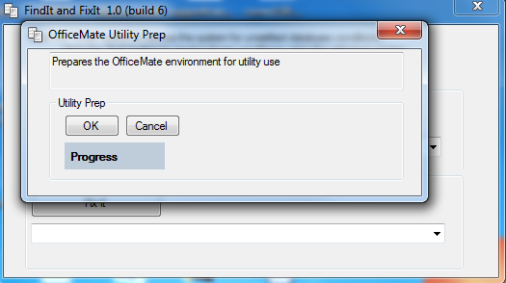

- This will prep the system including copying the database.

- Click the OK button when the process completes
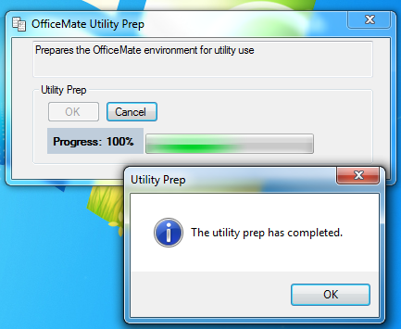

- The main FindIt-FixIt screen will display
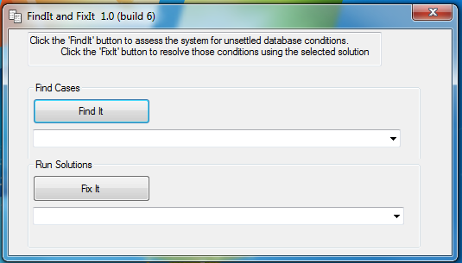

- Select a solution from either the FindIT or FixIT dropdown box, and then click the FindIT/FixIT button. The support representative must start from a solution that references this utility, and that number should be selected. The drop-down list will have solutions listed in the Eyeforce format “Solution Number – Solution Title” (see example screen shot): 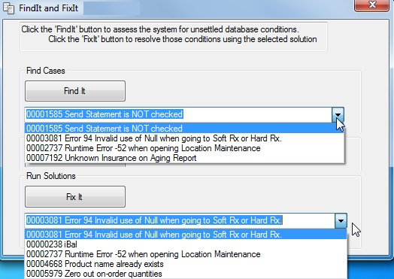

List of Solutions Used in the Utility

238 | iBal Utility : Ledger, A/R Reports, error 3021
726 | Third Party Processing - Error 217900 - Incorrect syntax
1579 | Error 94: Invalid Use of Null clicking Insurance Tab in Patient Demographic
1585 | Patients are not getting statements because Send Statement is NOT checked.
1585 | Send Statement is NOT checked
2737 | Runtime Error 52 when opening Location Maintenance
3081 | Error 94 Invalid use of Null when going to Soft Rx or Hard Rx.
4668 | Product name already exists" but not showing as inactive
5979 | How to zero out 'on order' quantities on the Frame stock status report
7192 | Unknown Insurance on Aging Report

What is the difference between FindIt and Fix
FindIT allows the user to determine if data conditions exist that would warrant the use of a solution. In some cases, an interactive user interface will display allowing the user to Fix the issue.

FixIt will run sql scripts mainly without an interactive user interface. These may be solutions that act on a large number of records, where a user interface is not appropriate, such as zeroing out on-hand order quantities. FixIt will also launch other utilities such as iBal.exe, without the need to download a separate file to the client’s workstation.

What to do after using FixIt

- Delete any files copied to the client’s desktop including: FixIt.exe, iBal.exe, UtilityPrep.exe. The latter two files may be automatically deleted but always check the desktop.

- Copy the log from the user’s Officemate\Data or omate32\data folder, and attach it to the case.

- Display this log file for the client and explain the information.

- Offer to save, email, or print the log for the client for their recordkeeping.

When should FixIt not be used

- Do not use FixIt when the support technician is logged-on the server. The utility is currently made to run specifically from a workstation, not the server where the OfficeMate SQL Server is installed. Follow the manual solution instructions when logged-on the server.

- Do not use FixIt with OfficeMate Version 8 SQL. Follow the manual solution instructions.

- Do not use FixIt when logged-on a workstation, but OfficeMate is running using terminal services. Follow the manual solution instructions.

Printing & Copying the information from the solution activity
A log file is created for every solution run by FixIt. This log is created in the local OfficeMate/Data or omate32/Data folder.

A listing can also be created by:

  - Clicking on the top left cell of a grid of to select all the rows of data.

  - Pressing the keyboard keys Ctl-c to copy all rows.

  - Pressing the Ctl-v to paste information into common windows applications.

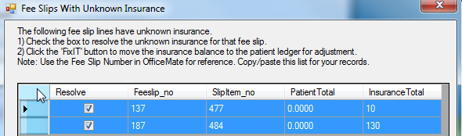

Troubleshooting & Errors

FixIt will significantly improve the customer experience and save time in resolving issues.
As with all software, every office environment has the potential to present a new technical scenario with unexpected results. When that happens document the following and report the behavior to the developer:

- Workstation Operating system, CPU, Memory.
- Server Operating system, CPU, Memory.
- Local installation, Terminal Server, or Hosted Solution (ThinkSmart, iManaged, other).
- When the error occurred.
- The solution number.

Use taskmanager.exe to end the FixIt process, when necessary.

Open Task Manager using any of the following methods:
• Press Ctrl-Shift-Esc.
• Right-click an empty area of the taskbar, and then click Task Manager.
• Press Ctrl-Alt-Delete, and then click Task Manager.

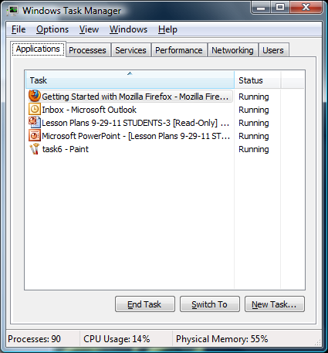
You'll see a list of the programs ("tasks") currently running on your machine. Look for FixIt.
- To exit FixIt, select FixIt.exe and click the End Task button. This feature is useful when the program is no longer responding to input commands.
- If this does not end FixIt, click on the “Processes” tab
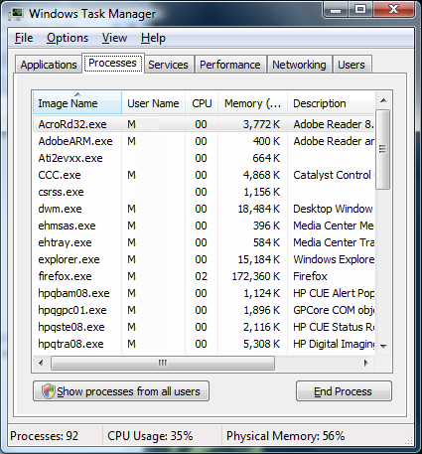
Here you'll find a list of processes (instances of programs) running. Ending the process of a nonresponsive application is sometimes the only way you can shut it down. Look for FixIt.exe in the list.
1. To end the FixIt.exe process, right-click the application's entry in the Applications tab and click Go To Process. The applicable process will be highlighted in the Processes tab.
2. To end a highlighted process, click End Process. You'll want to terminate an application in this manner when clicking End Task in the Applications tab doesn't work.
3. Right-click a process and then click End Process Tree to end the process and all associated processes.

Feedback
We want to hear from you. Let us know how the utility can be improved.
Email feedback to curtis.witcher@eyefinity.com

